**NAME: JEEVITHA.S-192324020**

**DATA BASE MANAGEMENT SYSTEM FOR DATA APPLICATIONS(CSA0555)**

**ASSIGNMENT 1: TRAFFIC FLOW MANAGEMENT**

**RELATIONAL MODEL:**

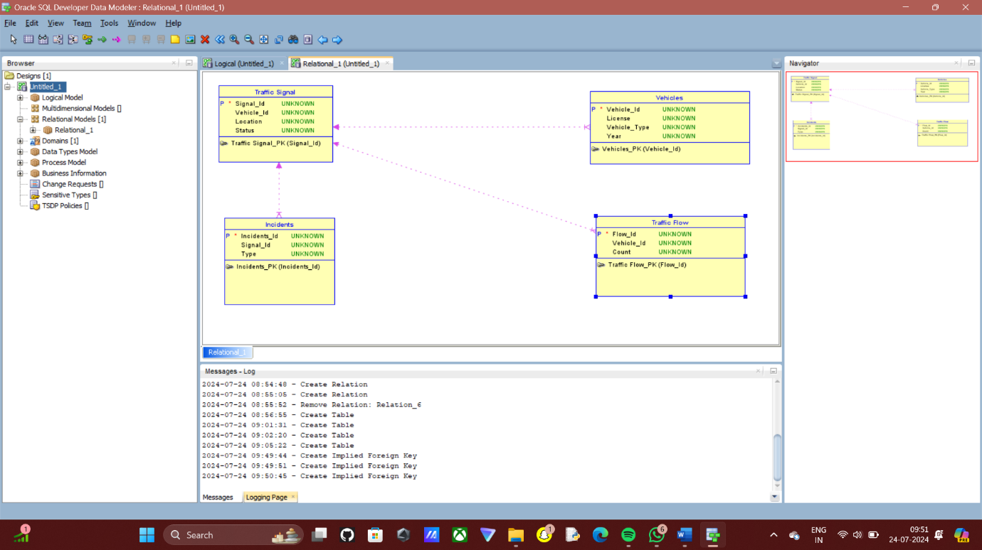

**LOGICAL MODEL:**

